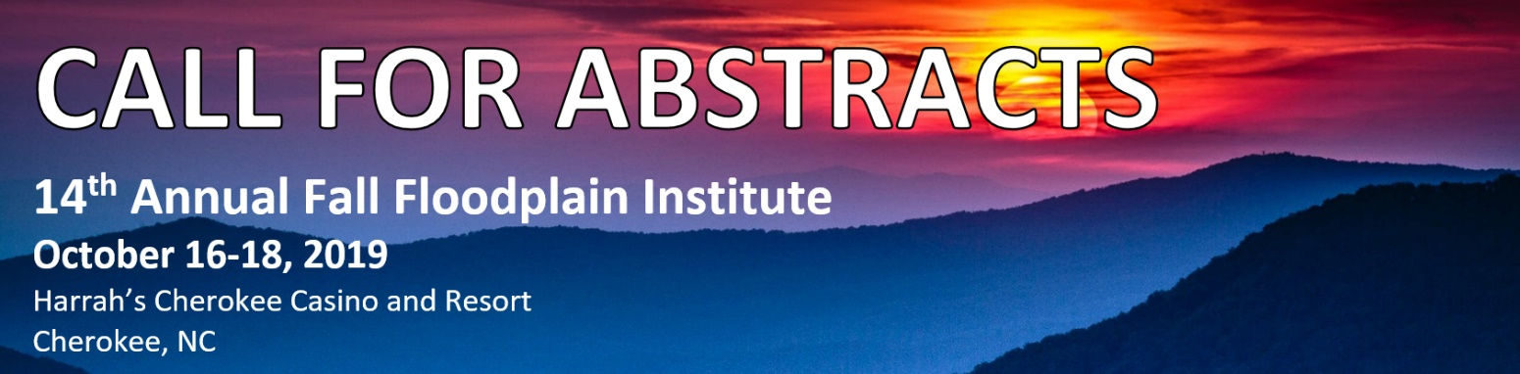

***The North Carolina Association of Floodplain Managers (NCAFPM) will host our Fall Floodplain Institute on October 16-18, 2019 in beautiful Cherokee, North Carolina!***

This Call for Abstracts seeks a broad range of professionals to address the many issues and problems associated with reducing flood damages, making communities more sustainable and managing floodplain and fragile coastal resources.

**Suggested topic areas include:**

* Floodplain Mapping
* GIS - LIDAR - Other Technologies
* Mitigation Planning
* Mitigation Success Stories
* Stream Channel/Wetlands Restoration
* NFIP and Floodplain Management
* Hurricane Matthew and Florence Success Stories
* Community Relations
* Recent Flood Events/Lessons Learned
* Storm Water Programs/Funding
* Hydrologic/Hydraulic Modeling
* Community Rating Systems
* Local Building Code Issues
* Legal Issues
* Other Related Topics

Total presentation time is limited to 25 minutes (20 minutes for the presentation and 5 minutes for Q&A). If you are interested in presenting a topic, please e-mail to David Key ([dkey@espassociates.com](mailto:dkey@espassociates.com)) the following items:

* Title of presentation
* Brief abstract of your presentation (a sample can be found on the Fall Floodplain Institute page of the NCAFPM website)
* Name of presenter(s)
* Brief biography of each presenter
* Affiliation
* Address, Telephone Number and E-mail Address

***Abstracts should be submitted prior to July 26, 2019***. Presenters will be notified of acceptance by early August. Presenters should be prepared to speak for their entire allotted time.

**2019 FFI Program Chair**

David Key ([dkey@espassociates.com](mailto:dkey@espassociates.com))